**SQL Queries**

1. This query is for finding work status of lab on the basis of time taken to complete soil analytical test and price taken by lab. This query can be used to check labs are doing their work properly or not.

SELECT provides_soil_analysis.Lab_ID, Lab_Name, Contact_No, Area_Name, provides_soil_analysis.Test_ID,

amount_paid, F_ID, DATEDIFF(Report_recieved_date,sample_given_date) as days_for_test,

CASE WHEN DATEDIFF(Report_recieved_date,sample_given_date)>14 AND amount_paid>1800 AND

provides_soil_analysis.Test_ID='T30789' THEN 'Expensive and late'

WHEN DATEDIFF(Report_recieved_date,sample_given_date)>14 AND amount_paid<=1800 AND

provides_soil_analysis.Test_ID='T30789' THEN 'late with ok price'

WHEN DATEDIFF(Report_recieved_date,sample_given_date)<14 AND amount_paid>1800 AND provides_soil_analysis.Test_ID='T30789' THEN 'On time and expensive'

ELSE 'On time with ok price'

END as deal_status

FROM soil_analytical_lab,provides_soil_analysis

WHERE soil_analytical_lab.Lab_ID=provides_soil_analysis.Lab_ID;

Output:

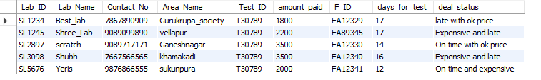

1. This query gives farmer's current season's wheat production details, price status and give the output in the ascending order of expected price. This query will be used by crop buyer.

SELECT current_season_crop.F_ID,First_name, Contact_No, Expected_production, Expected_price,

CASE WHEN Expected_price>220 THEN 'expensive'

WHEN Expected_price<=220 THEN 'affordable'

END AS price_status

FROM farmer, current_season_crop

WHERE state='Gujarat' AND Expected_production>200 AND

crop_ID='WH123' AND crop_delivery_month='July' AND crop_delievery_year='2000' AND

current_season_crop.F_ID=farmer.F_ID

ORDER BY(Expected_price) ASC

LIMIT 5;

Output:

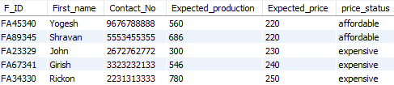

1. This query gives farmer's list fulfilling some conditions about their last season crop details. This query can be used for analysis purpose.

SELECT farmer.F_ID,First_name, Contact_No,Address, previous_season_crop.production,state,district

FROM farmer,previous_season_crop

WHERE sowing_month='January' AND harvest_month='May' AND sowing_year=2000

AND harvest_year=2000 AND previous_season_crop.crop_ID='WH123' AND previous_season_crop.F_ID=farmer.F_ID

AND production= ANY (SELECT production

FROM previous_season_crop

WHERE production

BETWEEN 200.0 AND 500.0)

ORDER BY(production) ASC;

Output:

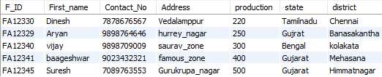

1. This query gives detail about those fertilizer dealers selling fertilizer than normal price and having stalk more than normal.

SELECT fertilizer_dealer.Fd_ID, Contact_No, First_name, fertilizer_availability.Price, Available_stock, District, Area_Name

FROM fertilizer_dealer, fertilizer_availability

WHERE fertilizer_availability.Fertilizer_ID='FE1232'

AND EXISTS (SELECT price

FROM fertilizer_availability

UNION

SELECT Available_stock

FROM fertilizer_availability

WHERE price>500 AND Available_stock>=20) AND fertilizer_availability.Fd_ID= fertilizer_dealer.Fd_ID AND state='gujarat'

ORDER BY (fertilizer_availability.Price) ASC;

Output:

